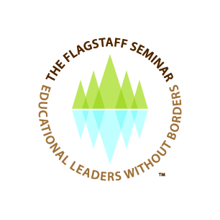
2ND Meeting, San Francisco May 1, 2013

Meeting for the second time on May 1, 2013, a group of eighteen prominent national and international scholars met in San Francisco and recommitted themselves to confront issues of poverty faced by school children in the world and to work towards global improvement in the education of girls. These urgent matters are a worldwide problem with over 100 million children not in school, the majority being girls. The group is known as the Flagstaff Seminar, “Educational Leaders without Borders and consists of an invited and select group of academics and practitioners representing Kappa Delta Pi, International Honor Society in Education, the Nigerian Professors of Education Administration, the National Council of Professors of Education Administration, and premiere scholars from Australia, Canada, and the U.S. It was hosted by Dr. Rosemary Papa, the Del and Jewel Lewis Endowed Chair in Learning Centered Leadership and Professor of Educational Leadership in the College of Education at Northern Arizona University, and Fenwick W. English, the R. Wendell Eaves Senior Distinguished Professor of Educational Leadership at the School of Education at the University of North Carolina at Chapel Hill.
The two primary thrusts surrounding how to enable FS research to activism was seen as a clear call to action for the participants to continue their work towards ensuring that education is a basic human right and that educational leaders can and must become emboldened to seek solutions that go beyond the school house door, even if this means confronting historic cultural and political forces that act as barriers to basic improvements in the reach and quality of education in the world.
Participants included Faye Snodgress, Executive Director of Kappa Delta Pi International Honor Society in Education; Dr. Nathan Bond, recent past president of Kappa Delta Pi and Associate Professor at Texas State University; Dr. Uche Grace Emetarom, Professor and President of the Nigerian Professors of Education Administration; Dr. James E. Berry, Professor of Leadership and Counseling at Eastern Michigan University and Executive Director of the National Council of Professors of Education Administration. Other participants were: Dr. Concha Delgado Gaitan who is a former Professor of Sociocultural Studies at the University of California, Davis. She is an award winning researcher in anthropology and education; Dr. Lisa Ehrich, Associate Professor, Queensland University of Technology, Australia; Dr. ShelleyAnn Scott, Associate Dean, University of Calgary, Canada; Dr. Donald E. Scott, Leadership Assistant Professor, University of Calgary, Canada; Dr. Carolyn M. Shields, Dean, College of Education at Wayne State University, Michigan; Dr. Michael R. Sampson, Dean, College of Education at Northern Arizona University, Flagstaff; Dr. Martha McCarthy, Presidential Professor at Loyola Marymount University, Los Angeles, California; Dr. Carol Mullen, Professor and Director of the School of Education and Associate Dean for Professional Education at Virginia Tech University, Virginia; Dr. Ira Bogotch, Professor, Educational Leadership & Research Methodology at Florida Atlantic University, Florida; Dr. Jane Clark Lindle, the Eugene T. Moore Distinguished Professor of Educational Leadership at Clemson University in South Carolina; Dr. Lynnette A. Brunderman, Associate Professor of Practice in Educational Policy Studies at the University of Arizona; Dr. Richard S. Brown, Adjunct Professor of Educational Statistics at Northern Arizona University.
The collective research and scholarship of the group spans four decades of national and international work and exceeds 100 books, handbooks and encyclopedias, as well as hundreds of research journal articles in most major North American, European, Australian and African nations .
The group has set the next meeting date of September 18-20 2014 in Flagstaff to meet again and continue the intentional work of the FS activities and research in becoming educational leaders without borders.
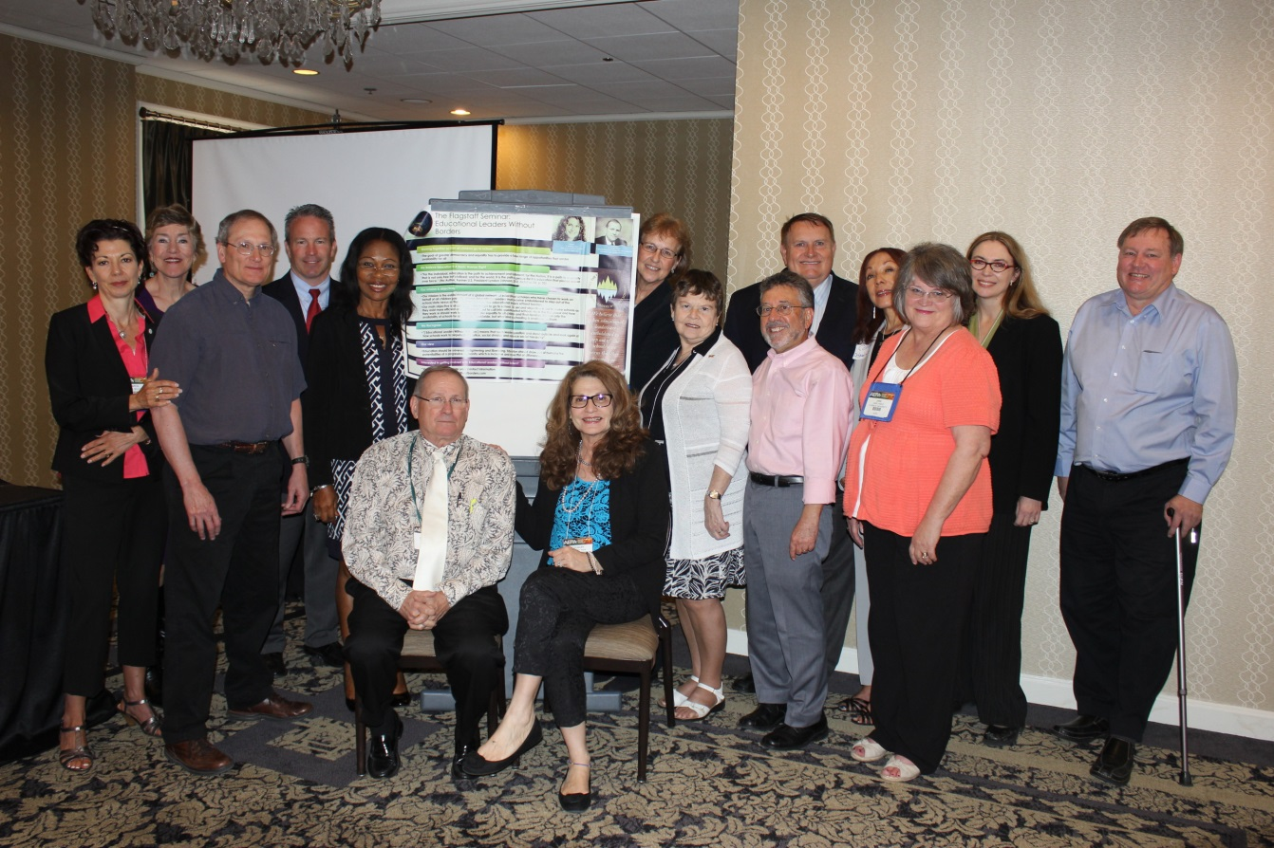
Standing left to right
Carol Mullen, Martha McCarthy, Jim Berry, Nathan Bond, Uche Grace Emetarom, Faye Snodgress, Carolyn Shields, Ira Bogotch, Michael Sampson, Concha Delgado Gaitan, Jane Lindle, Lisa Erich and Don Scott
Seated left to right
Fenwick English, Rosemary Papa
Not shown
ShelleyAnn Scott, Richard Brown, Lynnette Brunderman
FOR ADDITIONAL INFORMATION
www.flagstaffseminar.com
www.educationalleaderswithoutborders.com

FILE: FLAGSTAFF SEMINAR PRESS RELEASE

