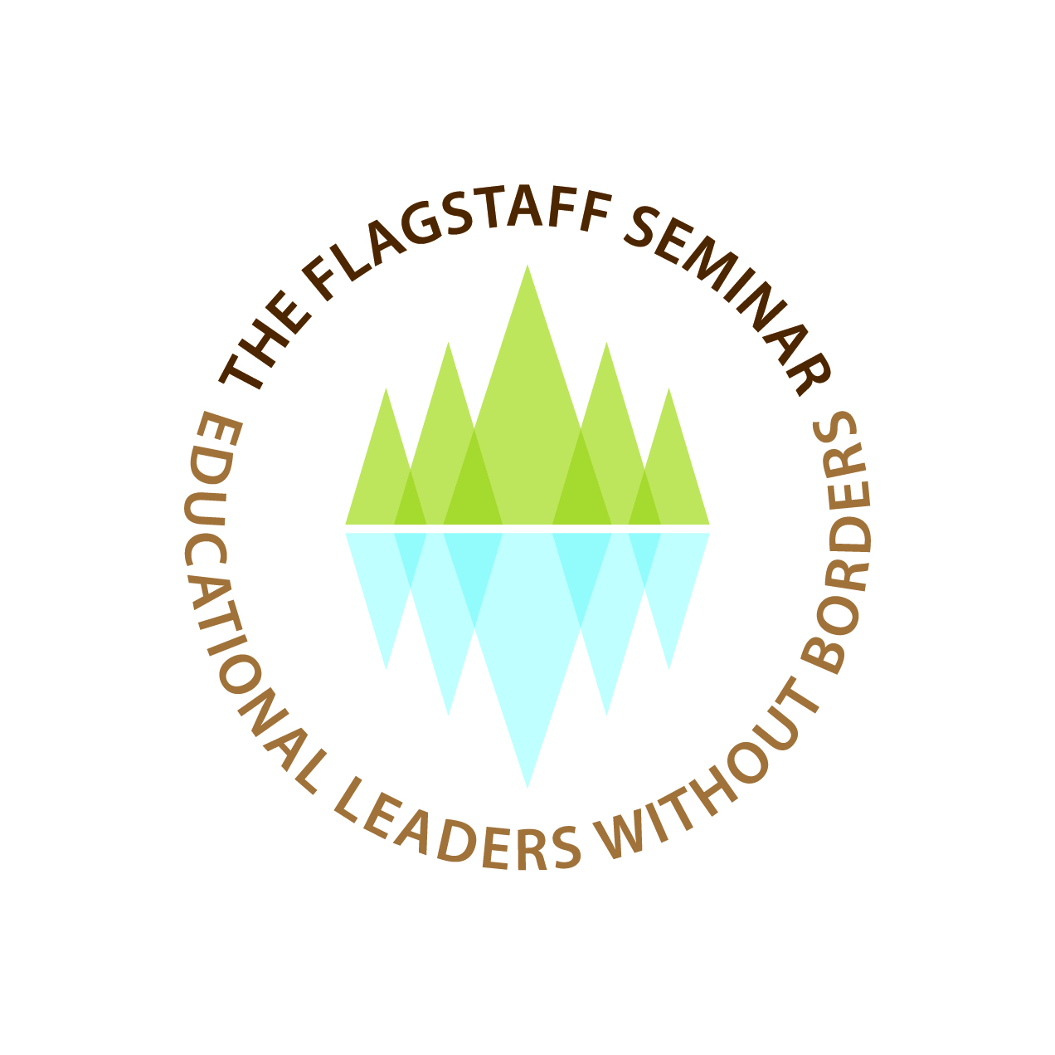
“Framing an International Imaginative Identity”

Rosemary Papa, Northern Arizona University, Flagstaff, Arizona Fenwick W. English, University of North Carolina at Chapel Hill

MONOGRAPH
2014

The Flagstaff Seminar:
Educational Leaders without Borders

We Recognize

All children have a right to go to school;

Education should draw out of humans the potentialities
of a progressive humanity which is inclusive and respectful of difference;

Schools are a leveraging institutional force for greater equality and opportunity;

Educational leaders can and must become emboldened to step out of the school/state nexus so that we can become true educational leaders without borders.

If it is accepted that truly democratic education is education
which sets itself the unconditional goal of enabling the greatest
possible number of individuals to appropriate, in the
shortest possible time, as completely and as perfectly as possible,
the greatest possible number of the abilities which constitute
school culture at a given moment, then it is clear that it is opposed
both to traditional education, which aims to train
and select a well-born elite, and to technocratic education,
aimed at mass production of made-to-measure specialists.

Pierre Bourdieu & Jean-Claude Passeron (1979)
The Inheritors (pp. 75-76)

Framing an International Imaginative Identity
At this point in the development of an identity for the Flagstaff Seminar (FS) “Educational Leaders Without Borders” it is clearer to us what we don’t want the FS to become. We are not interested in an organization which is chiefly:
- An academic debating society interested in only constructing an agenda which appeals to academic or scholarly matters to the exclusion of political, economic, and social issues impacting education and schooling in the nations of the world. Therefore we see an activist aspect of our work without that work becoming an international aid society or one which replicates aspects of domestic or international peace corps or other non-governmental agencies agendas;
- Advancing a socio-political agenda which is the province of any specific government, foundation or think tank and to function outside or in some cases, in spite of, those agendas. We remain skeptical of and not beholden to the academic, intellectual, cultural or historical precedents which continue to influence other scholarly, research, or academic organizations, whether they be those joined by individuals or by institutions. We want our efforts to be outside of these traditional spheres of influence to create the most intellectual and political space in which to function.
Inevitably, the intellectual and practical work we think that may be necessary to improve educational leadership and education in the social space in which we work becomes political, and as Bourdieu (1998) has indicated, “Constant, permanent relationships of inequality operate inside this space, which at the same time becomes a space in which various actors struggle for the transformation or preservation of the field” (p. 40-1). There is no supra agency which bestows legitimacy on what actors do in their social space, so legitimacy is a constant tension and involves contestation and competition for ideas, perspectives, directions, and ultimately resources.
We desire to have the maximum political landscape possible upon which to conduct our activities. For us, this is not a utopian vision, but a very practical one based on our experiences over three decades in many scholarly and practitioner organizations in the U.S. and abroad.
The bottom line for us is that we want to be free to define, adopt and implement what may become a very distinctive or even radical approach to work in our field across the world without having to worry about conservative elements or individuals in our organization threatening to prohibit, impede or block that work. We want the intellectual, conceptual and practical space to pursue our activities with the least amount of external interference as possible. We cannot think or act differently if we are forced to compromise at the outset what we are allowed to think about or do differently, even if it means doubting or rejecting any accepted or unquestioned dogma which may currently exist. Above all, we want to always question our own motives and operational logic so that we do not misrecognize them in conducting what is to become our work (English, 2012).
A Proposed Initial Demarcation of Our Work
A common global denominator for every country is underserved children. A total of 67 million primary school-age children were out of school in 2008 (UNICEF, 2011). The number of children in poverty is one billion, every 2nd child (Barnett, 1998). Even in a relatively prosperous nation such as the U.S., the Department of Education reported, “1,065,794 homeless kids were enrolled in schools in the 2010-2011 school year” (Huff Post, 2012, June, 28, p. 1). Since the start of the recession in 2007 this was a 57% increase in homeless kids. Additionally, the digital divide for the ‘haves’ and ‘have not’s’ exasperates the poverty when tied to the reality that “the internet is responsible for 21% of economic growth in developed nations (Alexander, 2012).
There are several movements occurring on a global platform, Education for All (EFA) and the Global Initiative on Out-of-School-All Children in School by 2015 (UNICEF, 2011), both of which are UNESCO and UNICEF initiatives. The EFA movement “is a global commitment to provide quality basic education for all children, youth and adults” (Education for All, 2012-1995, p. 1). Efforts to enroll children in school began with the EFA at an international meeting at Dakar in 2000, calling upon governments to address the “out-of-school children and to ensure equity in education” (p. 1). This led to UNICEF (2011) with UNESCO to launch a global initiative on Out-of-School Children in 2010 setting a goal of “universal primary education by 2015” ( p. 1).
Of critical concern is the fact that schooling is a cultural process whereby each nation defines and promulgates a specific cultural view to be imposed on some or all of its children. The main feature of the political process is that it is essentially arbitrary and the culture or cultures eventually included in the schooling process assume a privileged position over all other possibilities or alternatives which could have been selected. The process of selection is most often political and value laden.
And it seems nearly universal that those who control the schooling process use it to their advantage and to enhance, preserve and protect their own social position. The hierarchical nature of most societies ensures that those whose culture is most aligned with that of the school and its values will, in the words of Bourdieu and Passeron (1964) ‘inherit’ the benefits of the schooling process. Those student populations whose cultural orientation is less aligned or oppositional may find schooling to be abrasive, hostile, demeaning and alienating. Their reaction may range from passive resignation to active resistance to eventually leaving the school altogether. The statistics worldwide provide stark evidence of who benefits most and least from the forms of schooling which have been adopted by national states. It is not an accident that they cleave along lines of the values and perspectives of the dominant cultural outlook of those who control the schools.
In this analytic the most critical relationship involves that of the school and the state. And at the heart of this conversation is the matter of whether the individual is to serve the means and interests of the state solely, and/or if the state allows the individual the room and choice to develop his or her own humanity in ways which are congruent with becoming fully human, irrespective of the dominant interests and prejudices which typically are at work in schools of the state that are heavily influenced by social class, wealth, gender, race, religion or sexual orientation.
It is our belief that the FS should not only be concerned about who is and who is not in the schools worldwide, but the nature of the content and process of schooling which continually place some students, their families and cultures, at a disadvantage for the resources and rewards of the larger social system. If the schools are to be thought of as societal levers of opening up social position, wealth, and advancement to everyone, then the agenda of improving them has to be one in which the dominant content, values, pedagogy, and directions of schooling are closely examined to determine if that objective is even possible given the way social privilege is sanctioned and advanced by the schooling process. In other words, if the schools are the means by which advantage and disadvantage are advanced, it makes little difference if all children are in school if they are ultimately disadvantaged in their inclusion, but also come to believe and accept their inferior social position or opportunities which result from their own ‘inferiorities.’
We posit that the FS include in its focus the lack of availability to go to school as well the nature, content, pedagogy and operations of the functions of schooling and whether or not those aspects of schooling work to create a more level playing field for all children. The FS takes the position that schooling should be ubiquitous and a place where the potential of all children is recognized and valued, and the imposition of forms of cultural capital are adopted in a way that do not work to the perpetuation of privilege and dominance. This is the line of demarcation for us.
Our main objective is all children have a right to go to school. Our second objective is not to make schools as they exist more efficient at what they do, but to call into question what schools do in the first place and how they work or should work to provide greater equality to all children and their families. It is not only the availability of schools for all children worldwide, but what kind of schooling is available to them.
What Is an Educational Leader Without Borders?
For purposes of this concept paper, our view is that education should be universal, enlightening and liberating. Education should draw out of humans the potentialities of a progressive humanity which is inclusive and respectful of difference. In this we see at once how different the conceptualization of the purpose of schooling would or should be. Such a stance shifts the fulcrum between the school and the state from how can schools become universally available to all children, better and ‘fit’ all of the students into them, to one which asks, ‘what are students being fitted into’ and ‘why’ as well as who benefits most from such schools?
We believe that when educational leaders are emboldened to step out of the school/state nexus that they become true ‘leaders without borders.’ This distinction may be the most fundamental line of demarcation of the FS. We believe that humanity belongs to no one but itself. Education is not a means to somebody’s end, including the state, but education is the end unto itself. Education so conceived is the most open-ended process of development and democracy possible. A ‘leader without a border’ is someone who can be objective about their own role in a state system of education. It would be someone who can examine the school/state nexus and ask questions about the ends desired by the state and whether or not such ends are good for all.
Educational leaders without borders require school leaders who are culturally proficient and who can approach cultural objectivity and personal bias to the greatest extent possible. The goal of greater democracy and equality has to provide a fuller range of opportunities that render availability for all. Secondly, we have to confront any idea of a ‘zero sum game’ in which what one set of students acquires must be taken from other students’ opportunities. This dilemma is a particularly potent source of pushback from parents who may see efforts to equalize the advantages of schooling as jeopardizing their own and their children’s social or cultural advantage. Not everyone will be happy with equalizing opportunity. But we see much of the pushback met with the idea of eliminating time served as the benchmark of schooling and as a means to enable the rapid advancement of all students ‘in the shortest time possible.’
And as part of the pedagogic process, we see “educational leaders without borders” as individuals who work to create a more socially just world society where inherited advantage is not reinforced and the wealth gap between ‘haves’ and ‘have not’s’ expanded as it is today (Wilkinson & Pickett, 2010).
Educational leaders without borders means that such leaders question and stand outside and look again at how schools work to perpetuate injustice, social division and reinforce social hierarchy. We see schools as a leveraging institutional force for greater equality and opportunity than they are in many of the wealthier more privileged Western nations.
If one accepts this goal as a desirable definition of an educational leader without borders, then we ought to anticipate the kind of objections and resistance to which it will be subjected.
A Notion About Democratic Education
The right to an education as both basic and innate is clearly found within the works and writings of Paulo Freire and the passion to which he devoted his life in the eradication of illiteracy in Brazil during the middle of the 20th century. Freire (1970) wrote of conscientização, a process of awareness (bab.la Dictionary, n. d., p. 1) to consciously and critically use education and learning in the shaping of the person and society. His writings did not stem from the traditional theorists, such as Plato, but were based in a view that education must be modern and non-colonial, and that of acquiring “education to which they have a right” (Freire & Macedo, 1993, p. 31).
Amnesty International (2012) seeks to ensure universal schooling as a human right. “Everyone everywhere has the right to live with dignity. No one should be denied their rights to adequate housing, food, water and sanitation and to education and health care” (p. 1). Amnesty International further explains its view on children’s rights as,
Across the world, children are denied their human rights. They miss out on their right to education. They are abandoned and left to fend for themselves on the street. They are recruited into armed forces. They are subjected to the death penalty and suffer many other forms of violence. (p. 1)
We began this paper with a quote from the work of Bourdieu and Passeron (1964) in which they proffered the concept of a rational pedagogy and a “truly democratic education” would consist of an approach which:
…sets itself the unconditional goal of enabling the greatest possible number of individuals to appropriate, in the shortest time possible time, as completely and as perfectly as possible, the greatest possible number of abilities, which constitute school culture at any given moment (pp. 75-76)
We think that this idea, if implemented, would invalidate pedagogic practices and organizational arrangements that give the school the power socially to sort students because some are not included in schooling; some come to school already behind the dominant school culture and others do not. For those students in school, tracking and grouping by ability based on tested attributes stretch out the time some students have to spend in schools because they are already “behind”, that is, their cultural misalignment places them at a disadvantage from the outset.
Once again, we believe the purpose of schooling is not to prepare humans as means to state ends of economic competition and domination or to feed a military machine, nor to subjugate children to religious doctrine that is socially unjust to all children’s equal treatment for schooling, but to a universal availability of education as a means to a fuller and more meaningful life, to perceive as accurately as possible and to understand as much as can be possible (in the shortest time possible). We do believe that atrocities are found everywhere around the globe that prohibit children from going to school and we believe no voice should go unanswered:
Malala Yousafzai, a Pakistani 14 year old girl, was shot in the head by the Taliban for her advocating female education and an end to Taliban atrocities. The Taliban have claimed responsibility for this action. As a very young activist she posted diary statements that were published by the BBC Urdu since she was 11. Her courage grew from her desire to go to school. (No Author, 2012, October 22, p. 13)
About one third of the world’s urban population lives in slum conditions (p. 1)…children and adolescents are among the most vulnerable members of any community and will disproportionately suffer from poverty and inequality. In addition to poor and marginalized children in slums, children living and working on the streets, those who have been trafficked and those engaged in child labour deserve special attention and targeted solutions. (UNICEF, 2012, pp. 1-2)
The de-coupling of the primacy of the state/school nexus, the shift away from education or schooling as a means to solely state approved ends, the more inclusive range of humane forms of knowledge and activities will be a formidable challenge to all states and their regulation and monitoring of the schooling process. We see the role of educational leaders as individuals who can stand outside this relationship and objectively assess and criticize it along lines of what does and does not contribute to the school as a means and as a place where all children not only learn, but become more fully human.
We also believe education is a basic human right. Former U.S. President Lyndon Johnson stated it this way,
For the individual, education is the path to achievement and fulfillment; for the Nation, it is a path to a society that is not only free but civilized; and for the world, it is the path to peace—for it is education that places reason over force.” (No Author, 2012, October 22, p. 33)
The Nature of the Next Steps
We propose that our mission is to concentrate efforts on the children not being served well in all countries around the world. We propose to establish a network of education scholars. Our work in San Francisco is to further define the educational mission of The Flagstaff Seminar: Educational Leaders without Borders and to develop plans for linkages to such educational organizations world-wide and other associations and groups; to create an action agenda that might be appealing for foundational support; and to design activities, projects and publications that will advance our agenda in the years ahead. We believe strongly that the time is now to build strong global bonds to further this work.
Framing an Agenda
Among the key recommendations from UNICEF (2012) call for urgent action that includes the identification and removal of barriers to inclusion, the promotion of partnership between all levels of government, and the pooling of resources and energies of international to community actors in the support of efforts to ensure that marginalized and impoverished children enjoy their full rights. These are some of the compelling reasons that have given rise to FS scholars coming together.
How can a network of scholars respect the ethical and cultural differences that exist within state, regional, national, and international boundaries while helping children in need of schooling? These are the questions that undergird the continuing dialogue among The Flagstaff Seminar world-wide scholars.
The question then becomes what practices, traditions, assumptions of both the availability and social construction of schooling worldwide must be enhanced, changed or abandoned and what then might be invested in their places? We are reminded by Ash (2012) that, “the challenge of our time is precisely to build on values that are defensible in the light of reason and can be found across cultures” (p. 35).
- How do scholars become citizens of the world?
How can educational leaders think above national boundaries and politics?
- How should we think about children that are not being served well in educational systems in the world? What are the commonalities? What are the discommonalities?
What barriers prevent all children from going to school? What barriers prevent all children from doing well in schools as we know them?
- What is meant by leaders without borders?
Whereas a doctor without borders deals with patients irrespective of their religion, caste, sect, gender, race or political persuasion, how do educational leaders traverse the same borders since these are known to be barriers? What are the cultural nuances one must know to prevent colonization of ideas from dominant societies?
4. What are the facets that to a nation's schools which consistently create inequalities based on wealth, gender, class, religion, and culture? [Note: A way to describe and measure the degree of social distance disparity between the haves and have nots is found in the Gini Co-efficient].
These questions must be foremost in our consciousness as we try to confront the crisis that faces education from the neo-liberal threat in the U.S. (Sandel, 2012), in the remainder of the world (Kimber & Ehrich, 2011), and the exponential chasm between ‘haves’ and ‘have not’s’ in access to schooling. It is truly a frightening vision to imagine a world where most people aren't educated because it requires too many tax dollars; because they are female; they are from a lower caste; they live rurally, or that they are educated, but only in a very narrow context that is intended to serve the needs of multinational corporations or a nation’s dominant culture. Education to foster critical thinking, education to create more expansive vision for the world we inhabit, in effect, education to create and/or preserve and advance democratic communities is increasingly being threatened (Charles, 2012).
Summary: The Concept of Participatory Parity
It is our hope that this brief monograph will be helpful in moving our conversation forward to enable the FS to frame a common agenda. We believe our combined efforts can lead to research and practices that move humanity as a whole forward beyond the confines of any political boundaries or what Nancy Fraser (2010) has called, “the post-Westphalian” nation state (p. 28). Former Ambassador Edward Marks stated:
The UN Security Council approved Resolution 1244 (1999) on Kosovo, the world’s major countries redefined the sovereign character of the nation state...The post-Cold War world has segued into what might be called the post-Westphalian world. Resolution 1244…change[s] the legal and theoretical structure of international politics. (Marks, 2000, p. 1)
Social justice issues, new technologies, and the interconnectedness of world economies, span the globe and many fall between the spaces of nation states and cannot be addressed by only one nation state.
Our final proposal to the FS is Fraser’s (2010) idea of ‘the principle of participatory parity’ be the hallmark as an outcome of the Flagstaff Seminar. This notion is that, “any substantive principle of justice by which we may evaluate social arrangements, the latter are just if, and only if, they permit all the relevant social actors to participate as peers in social life” (p.29). Consequently a norm would be considered democratically legitimate, “if, and only if, they can command the assent of all concerned in fair and open processes of deliberation” (p.29).

References

Alexander, A. (2012, February 6). Trends. 2012 Digital divide statistics: Infographic. Retrieved September 1, 2012 from http://ansonalex.com/infographics/2012-digital-divide-statistics-infographic/

Amnesty International. (2012). Human rights issues. Retrieved October 4, 2012 from http://www.amnestyusa.org/our-work/issues

Ash, T. G. (2012, November 22). Freedom & diversity: A liberal pentagram for living together. The New York Review of Books, 59(18), 33-36.
bab.la Dictionary. (n. d.). Conscientização: Portuguese-English translation. Retrieved October 4, 2012 from http://en.bab.la/dictionary/portugueseenglish/conscientiza%C3%A7%C3%A3o
Barnett, W. S. (1998, March). Long term cognitive and academic effects of early childhood education on children in poverty. Preventive Medicine, 27 (2), pp. 204-207. Retrieved August 31, 2012 from http://www.sciencedirect.com/science/article/pii/S0091743598902754
Bourdieu, P. & Passeron, J-C. (1979; 1964). The inheritors: French students and their relation to culture. R. Nice, Trans. Chicago: University of Chicago Press.
Charles, H. (2012). Personal communication.
Education for All (EFA). (2012-1995). Education for all movement. Retrieved October 4, 2012 from http://www.unesco.org/new/en/education/themes/leading-the-international-agenda/education-for-all/
English, F.W. (2012, May). Bourdieu’s misrecognition: Why educational leadership standards will not reform schools or leadership. Journal of Educational Administration and History, 44 (2), 155-170.
Fraser, N. (2010). Re-framing justice in a globalizing world. In T. Lovell (Ed.) (Mis)recognition, social inequality and social justice (pp. 17-35). London: Routledge.
Freire, P. (1970). Pedagogy of the oppressed. N.Y.: Herder and Herder.
Freire, P. & Macedo, D. (1993). Pedagogy of the city. N.Y.: Continuum Publishing Group.
Huff Post. (2012, June 28). Education: Homeless students top 1 million, U.S. says, leaving “advocates” horrified. Retrieved December 3, 2012 from http://www.huffingtonpost.com/2012/06/28/homeless-students-us_n_1635709.html
Kimber, M. & Ehrich, L. (2011). The democratic deficit and school-based management in
Australia. Journal of Educational Administration, 49 (2), 179-99.
Marks, E. D. (2000). From post-cold war to post Westphalia. American Diplomacy, p. 1. Retrieved November 30, 2012 from http://www.unc.edu/depts/diplomat/AD_Issues/amdipl_14/marks_westph.html
No Author. (2012, October 22). TIME, 180 (17), 13.
No Author. (2012, October 22). TIME, 180 (17), 33.
Sandel, M.J. (2012). What money can’t buy: The moral limits of markets. New York: Farrar, Straus and Giroux.
UNICEF. (2011). Global Initiative on out-of-school children: UNICEF and the UNESCO institute for statistics. Retrieved on May 1, 2012 from http://www.unicef.org/infobycountry/files/Final_OOSC_Flyer.pdf
UNICEF. (2012). The state of the world’s children, executive summary: Children in an urban world. New York: United Nations Children’s Fund.
Wilkinson, R. & Pickett, K.(2010). The spirit level: Why greater equality makes societies stronger. New York: Bloomsbury Press.

Appendix A
Personal Information
Dr. Rosemary Papa Dr. Fenwick W. English
The Del and Jewell Lewis Endowed Chair R. Wendell Eaves Senior Professor Learning Centered Leadership Educational Leadership
Professor, Educational Leadership School of Education
Northern Arizona University Uni. of North Carolina Chapel Hill
U.S. U.S.
Rosemary.Papa@nau.edu fenglish@attglobal.net
Cell 916 832 1336 Cell 919 451 1493

Appendix B

Purpose of the Meeting and of this Monograph
The purpose of the San Francisco meeting of the Flagstaff Seminar (FS) “Educational Leaders Without Borders” is to more clearly define our identity within the fields which overlap with ours and to determine what role (s) we intend to define and advance within those fields as they intersect with ours. We see the function of this paper as advancing that purpose.
Background for this Monograph
In May of 2012, a dozen invited education scholars attended what was then called an endowed chair seminar at Northern Arizona University in Flagstaff, Arizona. Professors and practitioners gathered together at the same table to discuss educational problems worldwide. There were colleagues from the United States, China, the United Arab Emirates and Canada. Each participant spoke about his/her personal research agenda and what s/he viewed as the most pressing problems facing education and our profession worldwide. A desire to meet again to further define an agenda for the group that came to be called ‘The Flagstaff Seminar’ with the motto educational leaders without borders is scheduled for May 1, 2013 in San Francisco. This paper is an initial attempt to frame the discussion for that meeting.

File: Flagstaff Seminar Monograph 2014

